The Title of Abstract
(Times New Roman font, size 14, Bold, centered)
<<One blank line>>
First A. Author^{1*}, Second B. Author², and Third C. Author³
(Times New Roman font, size 12, Underline the name of presenter, centered)
<<One blank line>>
¹ Affiliation of the A. Author (Department, Institute, City, Country)
² Affiliation of the B. Author (Department, Institute, City, Country)
³Affiliation of the C. Author (Department, Institute, City, Country)
*E-mail address of corresponding Author
(Times New Roman font, size 12, Italic)
<<One blank line>>
ABSTRACT
The abstract must be submitted in word format and is limited to 250 words. If it is necessary, supporting figures can be presented as part of the text and total content is limited to one page including supporting figures. (Times New Roman font, size 12)

Graphical Abstract [Compulsory] [See example below]

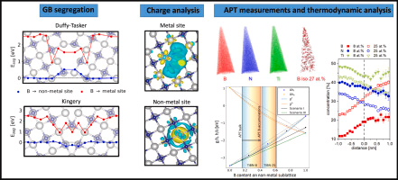

Keywords: More than 5 keywords required (e.g., Mechanical properties; Dynamic transformation; Microstructure; Tensile behavior; Precipitates)

References:
[1] A. Author et al., Name of published Journal or Book volume number (published year) pages.

